Resume Template

Contents

Login Screen 2

Invalid User Name & password 3

First Page 4

Next Button Press (Previous Button Visible) 5

Last Record (Next Button Hidden) 6

Manager Search 7

Software Search 8

HR Search (One Record found - Both buttons hidden) 9

No Results Found 10

Web-page resize 11

Back Operation Video 12

Credential Local Storage Effect 12

## Login Screen

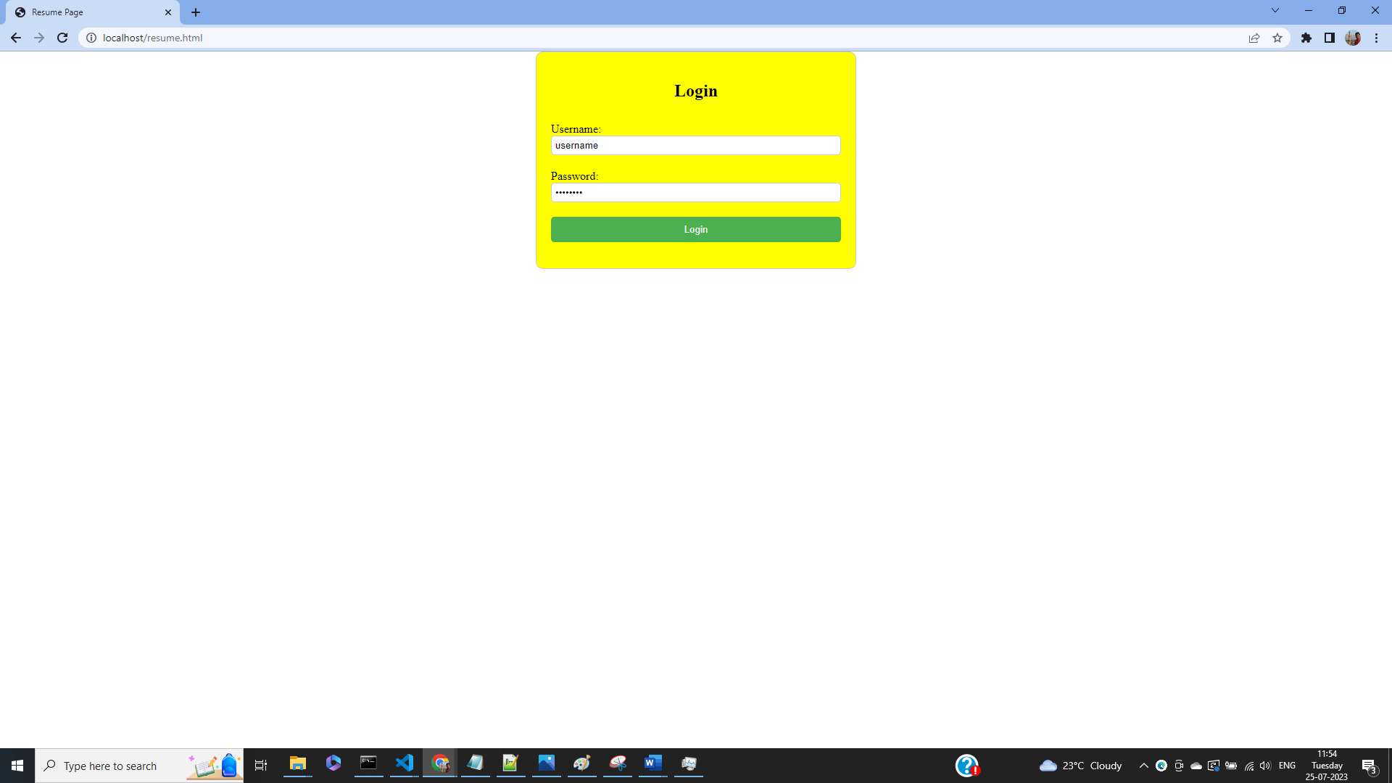

## Invalid User Name & password

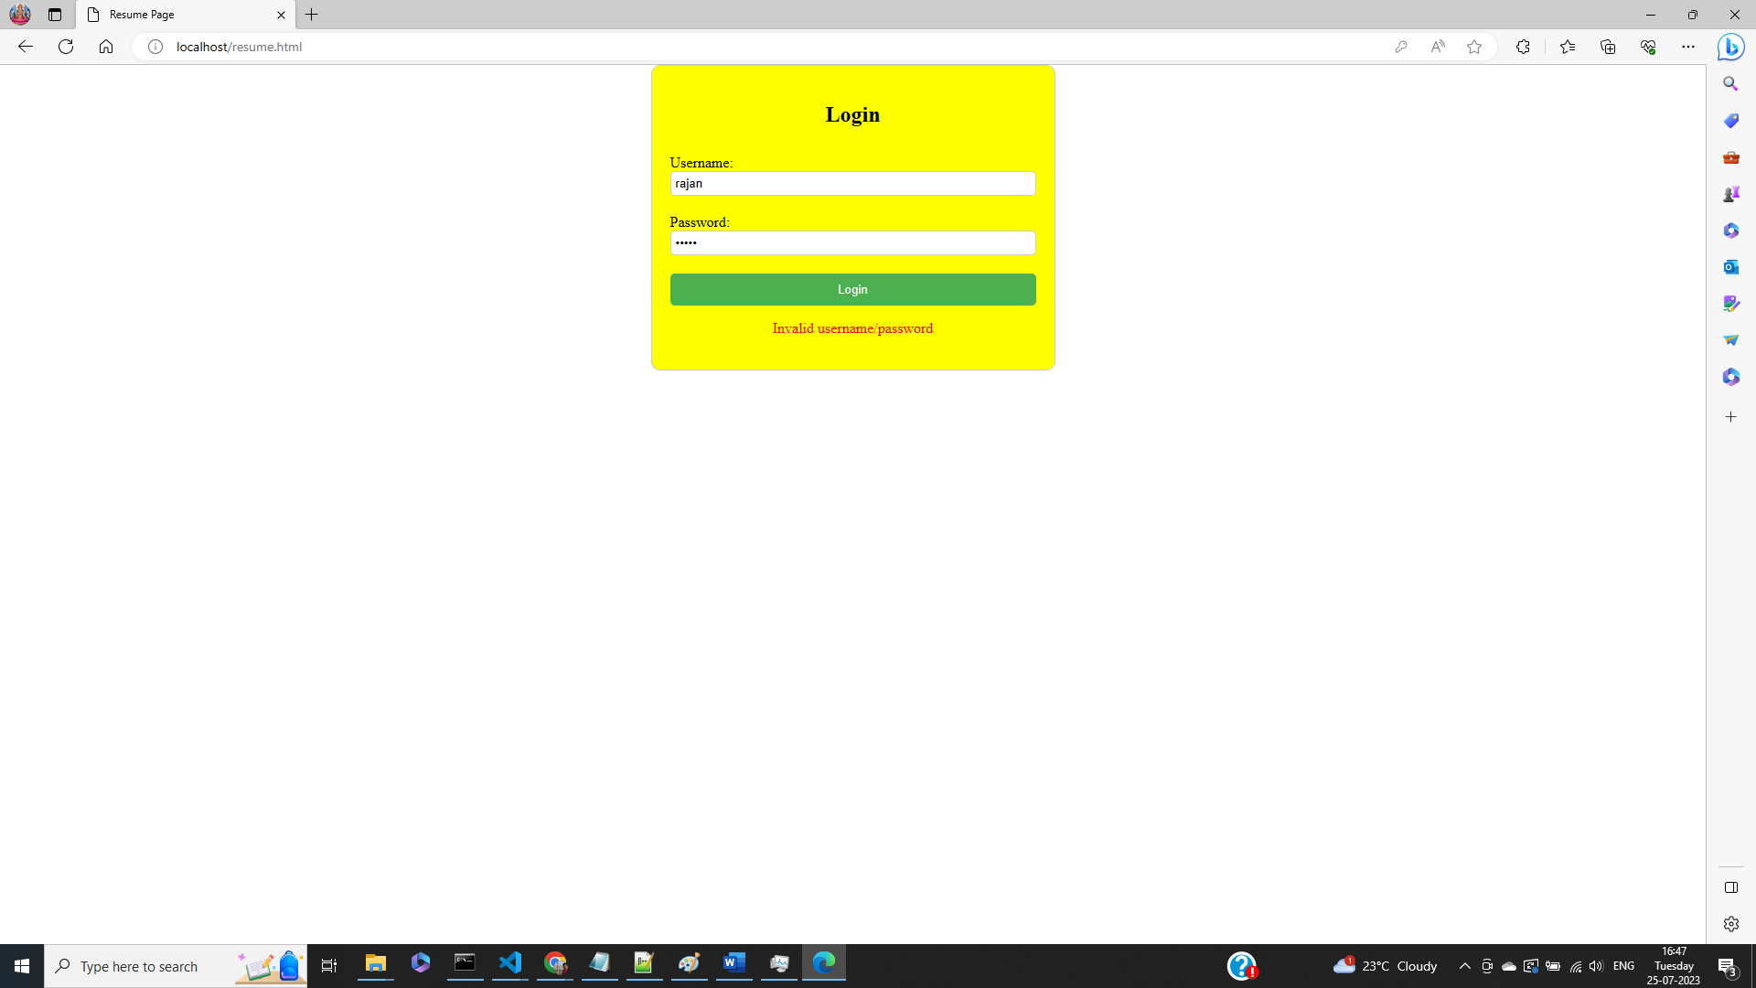

## First Page

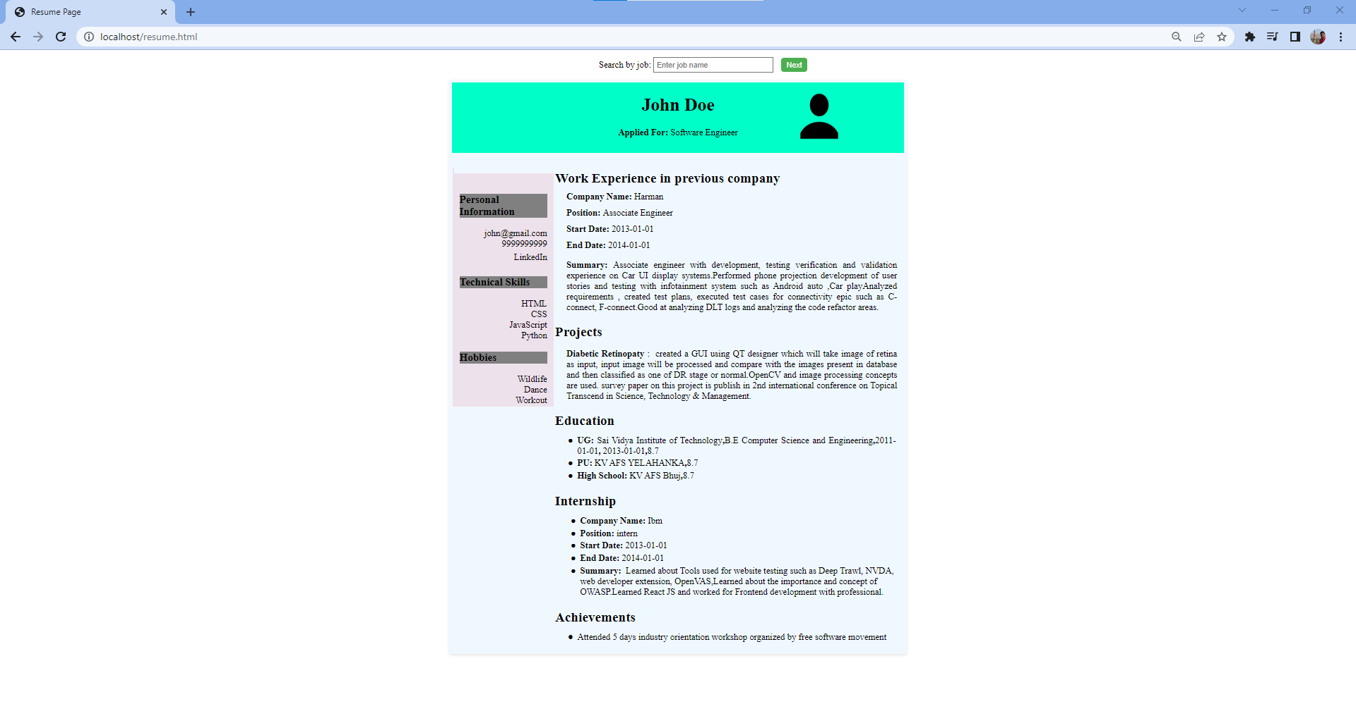

## Next Button Press (Previous Button Visible)

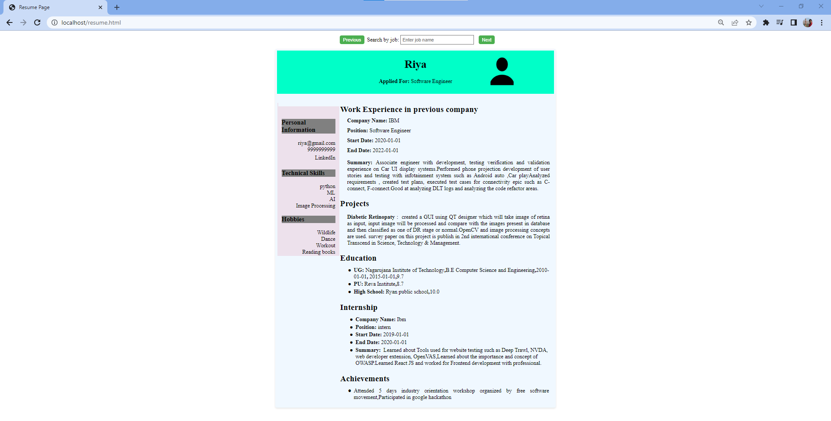

## Last Record (Next Button Hidden)

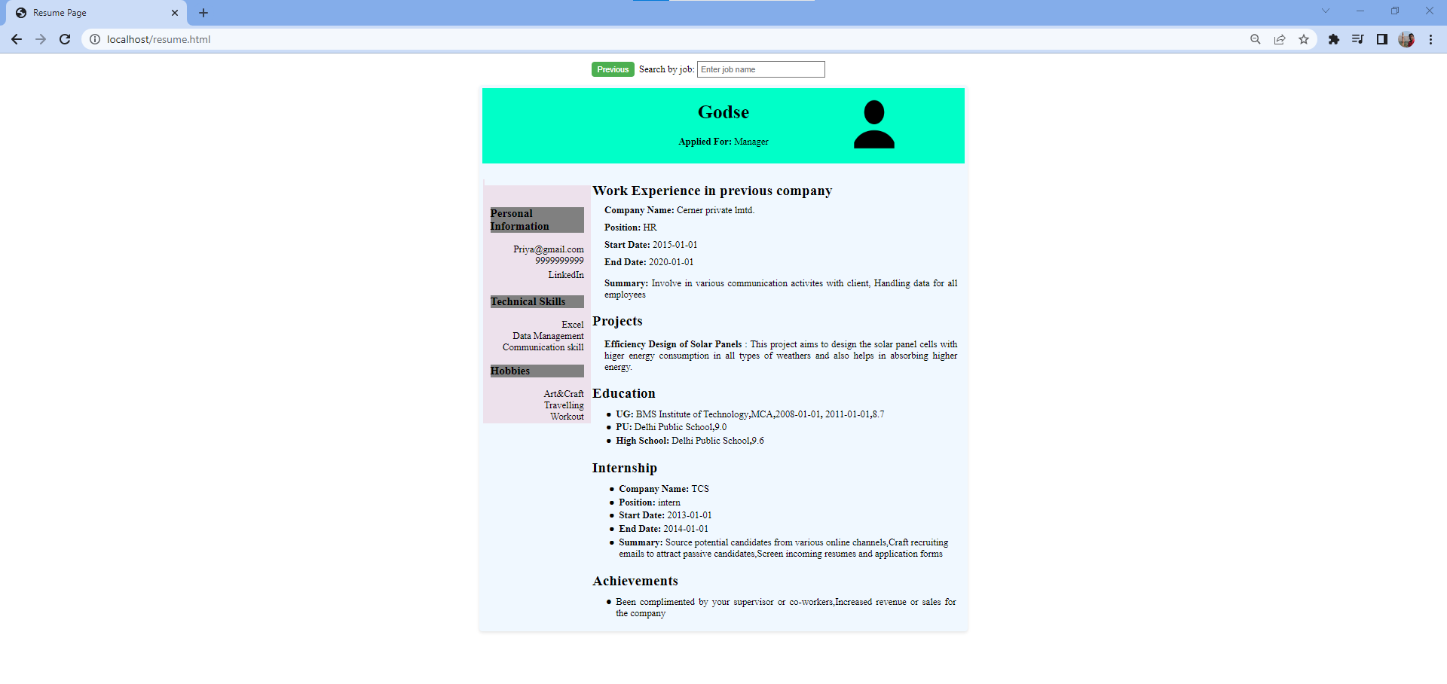

## Manager Search

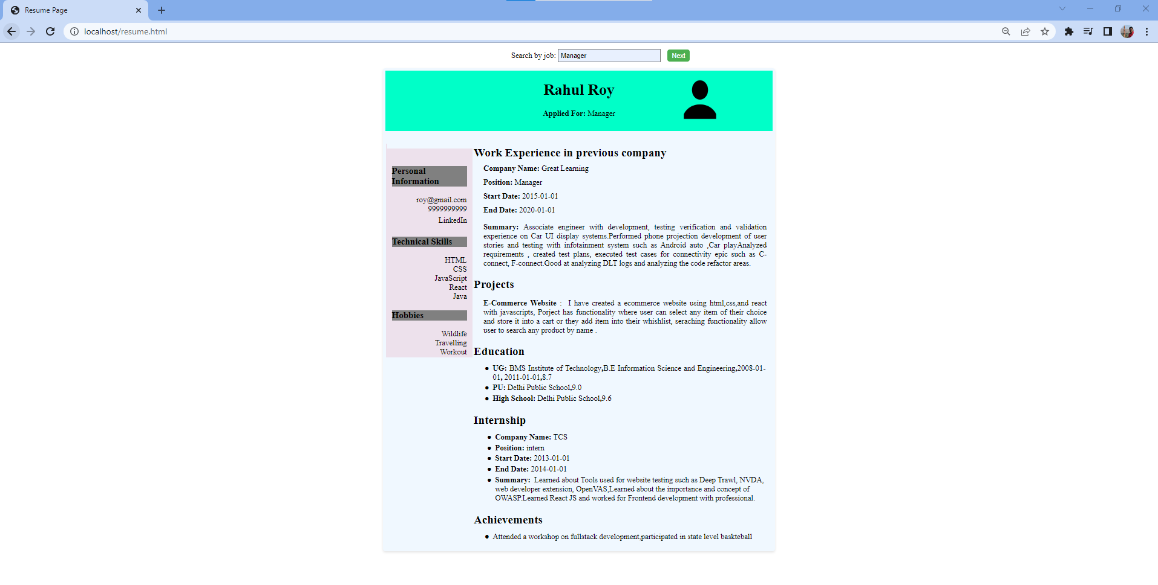

## Software Search

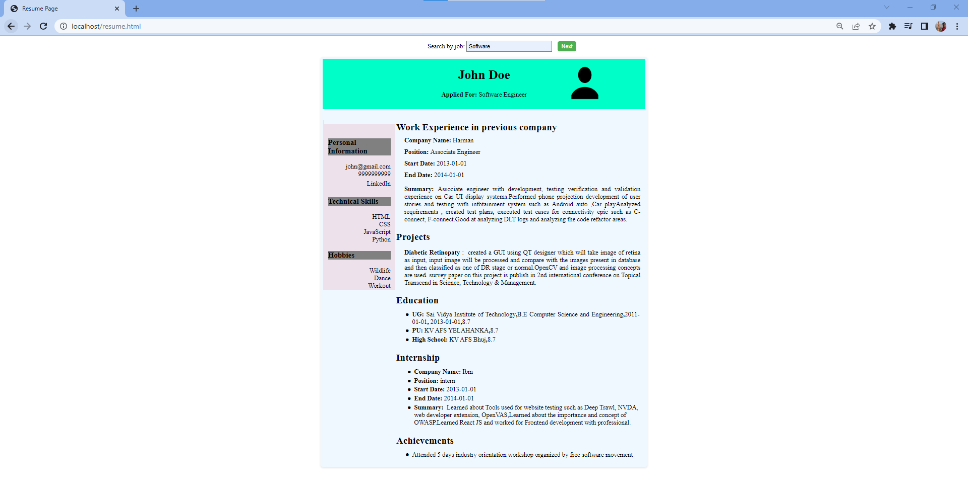

## HR Search (One Record found - Both buttons hidden)

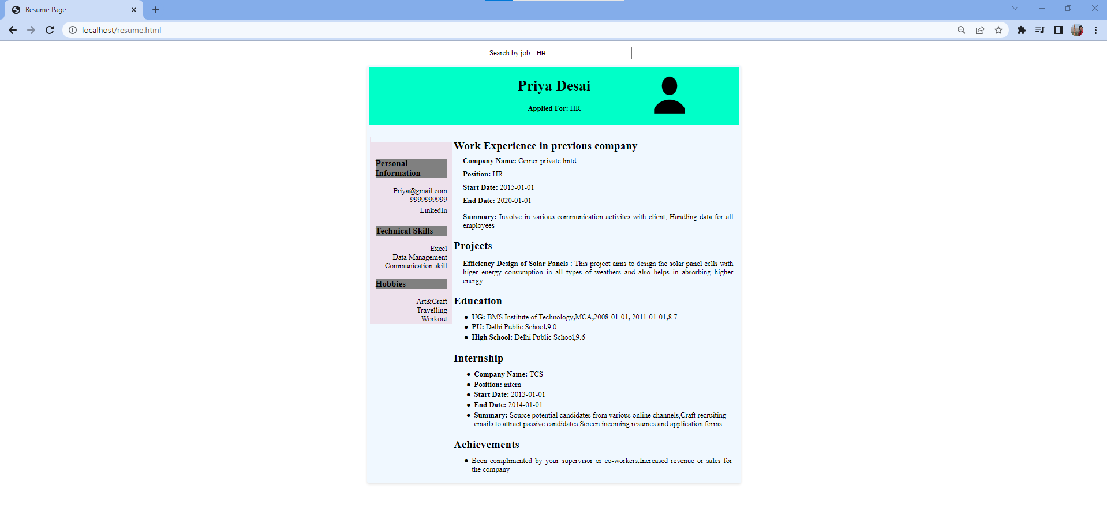

## No Results Found

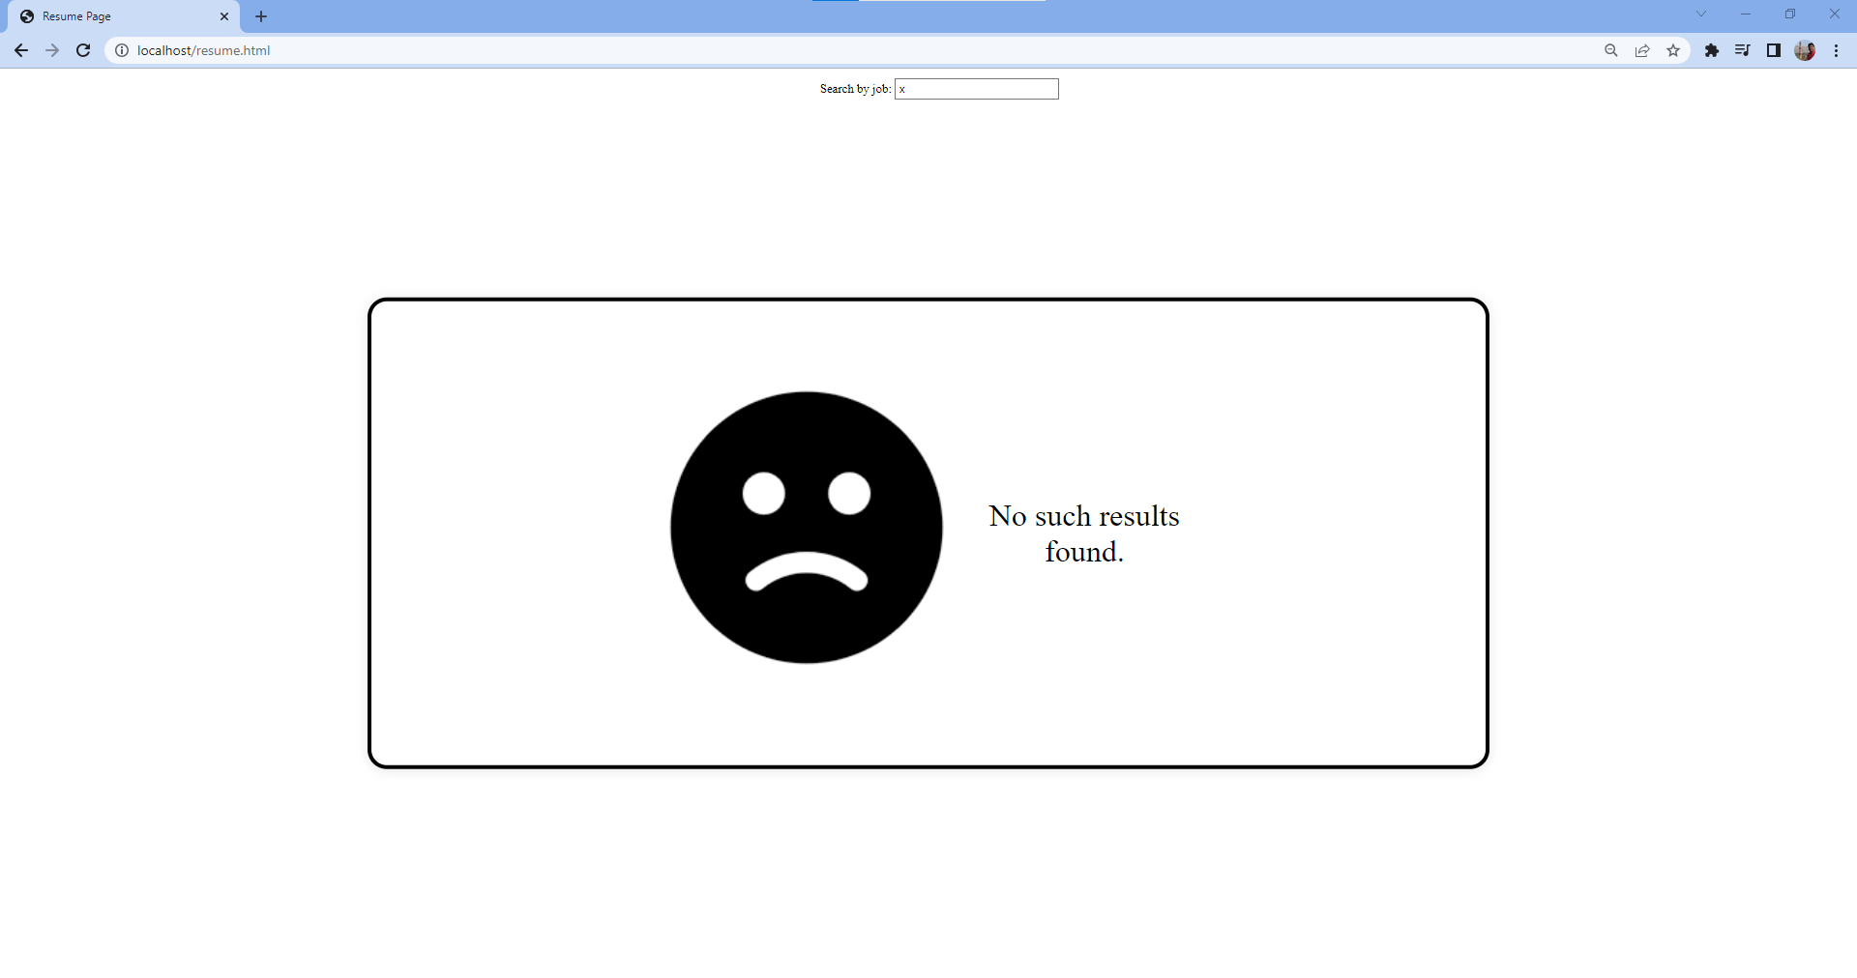

## Web-page resize

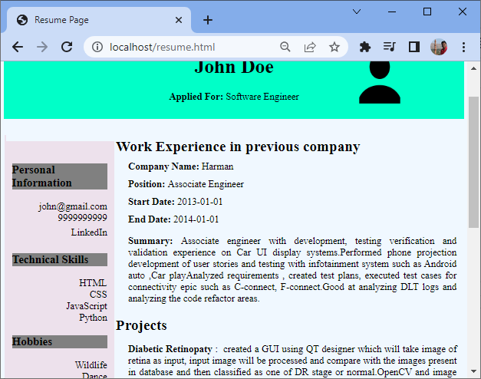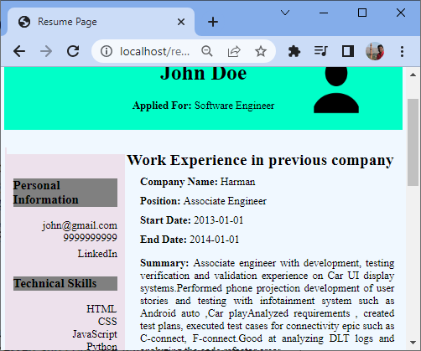

## Back Operation Video



## Credential Local Storage Effect

